ASSIGNMENT - 9.3
( 2403A52383 )

Task 1: Basic Docstring Generation

1.1 Manual Implementation
# Task 1: Basic Docstring Generation (AI Version)
def sum_even_odd_numbers(numbers):
"""Return sum of even and odd numbers in the given list.
Args:
numbers (list): List of integers to process
Returns:
tuple: (even_sum, odd_sum)
Example:
>>> sum_even_odd_numbers([1, 2, 3, 4, 5])
(6, 9)
"""
even_sum = 0
odd_sum = 0
for num in numbers:
if num % 2 == 0:
even_sum += num
else:
odd_sum += num
return even_sum, odd_sum
if __name__ == "__main__":
test_list = [1, 2, 3, 4, 5, 6, 7, 8, 9, 10]
result = sum_even_odd_numbers(test_list)
print(f"Input: {test_list}")
print(f"Even sum: {result[0]}, Odd sum: {result[1]}")

Output:
Input: [1, 2, 3, 4, 5, 6, 7, 8, 9, 10]
Even sum: 30, Odd sum: 25
Screenshot of Manual Code:
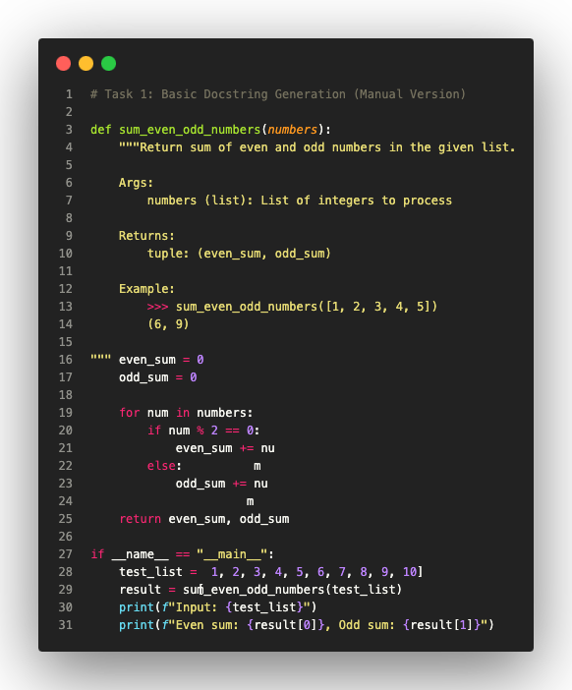

1.2 AI-Generated Implementation
AI Prompt: "Generate comprehensive docstring with Google style, error handling, and examples"
# Task 1: Basic Docstring Generation (AI-Generated Version)
def sum_even_odd_numbers_ai(numbers):
"""Calculate the sum of even and odd numbers from a given list.
This function processes a list of integers and computes separate
sums for even and odd values with comprehensive error handling.
Args:
numbers (list of int): A sequence of integer values to process.
Returns:
tuple of (int, int): A two-element tuple containing:
- First element: Sum of all even numbers
- Second element: Sum of all odd numbers
Raises:
TypeError: If input is not a list or contains non-integers.
Examples:
>>> sum_even_odd_numbers_ai([1, 2, 3, 4, 5, 6])
(12, 9)
>>> sum_even_odd_numbers_ai([])
(0, 0)
Note:
Zero is considered an even number.
"""
if not isinstance(numbers, list):
raise TypeError("Input must be a list")
even_sum = sum(num for num in numbers if isinstance(num, int) and num % 2 == 0)
odd_sum = sum(num for num in numbers if isinstance(num, int) and num % 2 != 0)
return even_sum, odd_sum
if __name__ == "__main__":
test_list = [1, 2, 3, 4, 5, 6, 7, 8, 9, 10]
result = sum_even_odd_numbers_ai(test_list)
print(f"Input: {test_list}")
print(f"Even sum: {result[0]}, Odd sum: {result[1]}")

Output:
Input: [1, 2, 3, 4, 5, 6, 7, 8, 9, 10]
Even sum: 30, Odd sum: 25
Screenshot of AI-Generated Code:
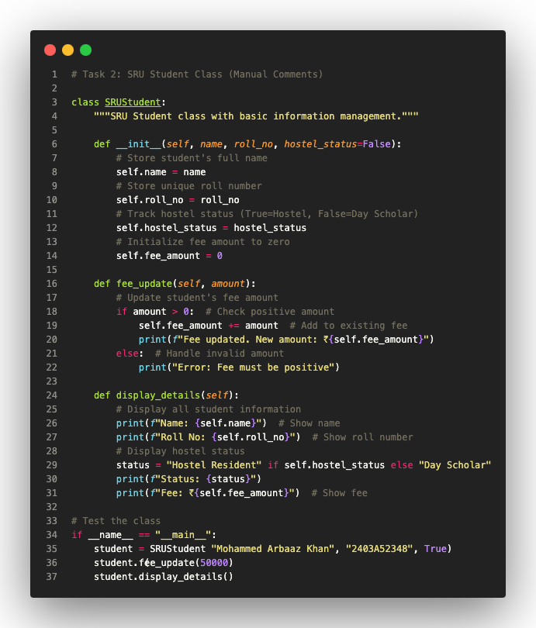

1.3 Comparison
Manual Docstring:
• Concise and focused
• Essential information only
• Beginner-friendly
• Google style basics
AI-Generated Docstring:
• Comprehensive and detailed
• Includes error handling
• Professional terminology
• Complete Google style with all sections

